CS1 – Design Document
Made by: Daniel Flegel

Contents
CS1 – Design Document 1
Introduction 3
Pfsense setup 4
VLANS 4
IP tables 4
VPN 4
Network Diagram 5
Windows AD setup 6
DHCP setup 6
Group policy setup 7
PowerShell scripts 8
Web Services 9
AWS 9
Website 9
Database 9
Windows Exporter 11
Node exporter 11
Prometheus 11
Grafana 11
Monitoring 12
Conclusion 13

Introduction
The goal of this project is to design and build a professional business network environment for a company that needs to host a public website while keeping its internal network secure, monitored, and reliable. The network should be able to operate consistently 24/7 while separating public services, internal servers, and employees to reduce security risks.

Pfsense setup

VLANS
The network will be divided into separate VLANs. This helps isolate the important parts of the network so that it is better protected while reducing the load on the employee network.
VLAN 1
VLAN 1 will be used for the company's internal servers and other important infrastructure such as domain controllers. This network will be highly protected because these systems contain important company data and services that need to remain available.
VLAN 2
VLAN 2 will be used by regular employees. Keeping employees on a separate VLAN prevents their devices from having direct access to the internal server network. This provides an additional layer of security and helps prevent a compromised employee device from easily reaching important servers.

IP tables
VLAN 1: 192.168.10.0/29
VLAN 2: 192.168.20.0/26
VLAN 2 will also use DHCP so employees do not have to manually configure an IP address on their devices. For now, the DHCP range will be 192.168.20.10 – 192.168.20.50 with a /26 subnet. This range can be changed later if the company needs more or fewer addresses.

VPN
OpenVPN has been setup so that the employees can work from home for example if they cannot reach the office. You can download the OpenVPN installer from pfsense where the configuration is already setup.

VPN setup
192.168.30.0/24
Max connections: 5 (can adjust to more or less if needed)
Local network: 192.168.20.0/26

Network Diagram
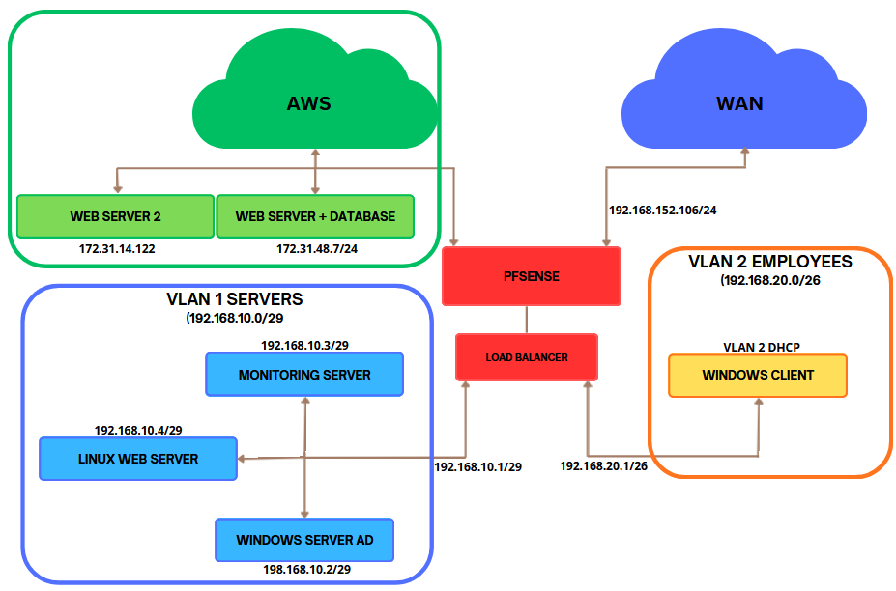

Windows AD setup
Each user will be assigned to a group based on their role. Instead of assigning permissions to every user individually, permissions will be managed through groups. This will make managing users much easier and more organized.
Each group will receive its own permissions and shared folders depending on what resources they need access to. This follows the principle of least privilege, meaning users only get access to the files and systems required for their work.
Permissions include:
- Access to shared folders
- Software installation rights
- Administrative permissions

The group structure of the domain (DualzIT.nl):
Group Name | Rights & Permissions | Shared Folder Access
Administration | Access to all folders in the domain | //Administration -  //Sales - //Management - //Employees
Management | Access to Management and Employees folder | //Management - //Employees
Sales | Access to HR folder | //Sales
ICT | Full administrative rights but no folders are assigned | X
Employees | Access to Employee folder | //Employees

DHCP setup
In this project VLAN 2 will have DHCP while VLAN 1 will be only static ip. This way the employees don’t need to manually configurate their ip addresses and VLAN 1 will have consistent Ip addressing.

VLAN 2 Employees
IP-range: 192.168.20.10 - 192.168.20.50 /24
Default gateway: 192.168.20.1
DNS: 192.168.10.2

Group policy setup
To protect the network from accidental mistakes made by employees, we will implement several Group Policies that restrict certain user actions and reduce the risk of security incidents.
The SecureNet group policy structure:
Affected users | Deny CMD | Disable USB | Disable software installation | Account policy | Deny Control panel
Administration | x |  |  | x | x
Management | x | x | x | x | x
Sales | x | x | x | x | x
ICT
Employees | x | x | x | x | x

What do they do?

Deny CMD
If an attacker gains access to a user account or computer, they could use Command Prompt or PowerShell to execute malicious scripts. To limit what an attacker can do inside the network, access to these tools will be blocked for regular employees. This should not affect daily work, since employees normally do not need to use these tools.

Disable USB Devices
If an attacker gains physical access to a computer, they could connect a USB device containing malicious software or scripts. To reduce this risk, USB storage devices will be disabled. While this may limit employees from using personal USB drives, the company provides network storage for work related files.

Disable Software Installation
Employees should not be able to install software freely, since malicious or untrusted applications could compromise the network. Therefore, only administrators will have permission to install software. Employees must request approval from IT before new software is installed.

Account Policy
Although Windows already includes default account security settings, additional restrictions have been implemented to improve security. Passwords must:
- be at least 8 characters long
- include special characters and symbols
- expire every 6 months
In addition, accounts will be locked after 3 failed login attempts for 10 minutes. This helps protect against brute-force attacks.

Deny Control panel
For the same reasons as disabling CMD, an attacker who gains access to a user account could try to manipulate system settings. To reduce this risk, access to the Control Panel is restricted and requires administrative rights. This should not affect normal daily work, as regular employees do not need to use these settings.

PowerShell scripts
In this project, a PowerShell script will run automatically to help manage and maintain the systems on the network. This script will be executed through Windows Task Scheduler, allowing administrative tasks to run without manual intervention.
If necessary, the scripts can also be executed manually. Instructions for manual usage will be stored in the scripts folder within the Windows Active Directory environment.

Update Installer
This script scans all devices on the network for missing Windows updates. If updates are missing, the script automatically forces the devices to download and install the required updates. This script will run after work hours.

Web Services

AWS
The public website will be hosted on AWS. Using AWS allows the website to be accessed from the internet without directly exposing the internal company network to public traffic. It also provides additional options for scaling the website if the number of users increases.
The website will communicate with the database hosted in the same AWS webserver. This keeps the website and its database close together while keeping both services separate from the internal employee network.

Website
The website is designed to be simple and functional. If new products need to be added or existing product information needs to be changed, this can be done directly in the database, and the website will update automatically. To reduce development time and costs, AI was used to assist with creating the website.

Database
MySQL will be used as the database for this project. Other database systems such as Microsoft SQL Server or PostgreSQL could also be used, but MySQL is relatively easy to configure and is more than sufficient for the size and requirements of this project.
Scalability is also considered when designing the database. The tables will be structured so that additional tables and features can be added later without causing conflicts with the existing database structure.

Database Tables:
Name of the table | Purpose
ID | Main identification for the products
Name | Name of the product
Sku | A unique code assigned to track and manage a product
Category | Category of the product
Price | Displayed price of the product
Stock | How much of this product are still in stock
Icon | Icon for the product
Short_description | Displays a short description of the product on the main page
Description | Displays a longer description in the product page
Specs | Show the specifications of some products like laptops
Created_at | Shows when the product was created/added

Load balancer
A load balancer will be used to distribute incoming traffic between multiple web servers. This helps prevent one server from becoming overloaded during peak traffic and improves the availability of the website. For this setup, two identical web servers will be hosted on AWS behind the load balancer. The load balancer will distribute incoming requests between the servers based on factors such as server availability and traffic. If one of the servers becomes unavailable, the load balancer can send traffic to the other server, helping keep the website online.

Fallback server
There will be a server made on VLAN 1 so that if the one on AWS fails or loses connection the Linux server in the vSphere environment will take over, it will also host the main website and the database so users can still order their products without having any issues.
Monitoring setup

Windows Exporter
Windows Exporter will be used to collect performance data from the Windows servers. It runs as a service in the background and automatically starts again when the server is restarted. This makes it useful for monitoring because no manual action is needed after a reboot.

Node exporter
Same as windows exporter, but it will collect data from the Linux server. The service will always run as a service in the background and automatically starts again when the server is restarted.

Prometheus
Prometheus will be used to collect and store the monitoring data provided by Windows Exporter. It will be installed on the monitoring server and regularly collects information from the Windows servers.

Grafana
Grafana will be used to display the monitoring data collected by Prometheus. Grafana is very easy to configure and adjust the dashboard, for now it will show data from the Active directory server and fallback webserver but it is possible to add more if needed. It will also be installed on the monitoring server.

Monitoring
Prometheus and Grafana will be used to monitor the servers and keep track of their performance. Monitoring is important for a network that needs to be available 24/7 because it allows IT technicians to notice problems before they cause a major outage.
For example, the Domain Controller will be monitored for:
- CPU usage
- RAM usage
- Disk usage
- Uptime
A basic alerting system will also be configured. For example, if CPU usage stays above 80%, an alert can be sent to the IT technicians by email. This allows them to investigate the problem and take action before the server becomes overloaded or stops responding.

Conclusion
The proposed network is designed to provide a secure and reliable environment for the company while keeping the different parts of the network separated. VLAN 1 is used for the internal servers and important infrastructure, while VLAN 2 is used for employees. This separation helps protect the internal servers from employee devices and reduces security risks.
Active Directory will be used to manage users, groups, permissions, and Group Policies. Additional security measures, such as restricting Command Prompt, USB devices, software installation, and Control Panel access, will help reduce the risk of accidental or unauthorized actions. A VPN is also available so employees can securely connect to the company network when working remotely.
The public website will be hosted on AWS together with the main database, keeping public traffic separate from the internal network. A load balancer will distribute traffic between multiple AWS web servers to help prevent overload during periods of high traffic. A fallback server on the internal network will also be available if the AWS environment becomes unavailable.
Prometheus and Grafana will provide monitoring for the servers and basic alerting. This allows IT technicians to detect performance or availability problems quickly and take action before they cause a major outage. Overall, the proposed design combines network separation, access control, redundancy, load balancing, and monitoring to create a reliable environment for the company.

